HOME TREATMENTS OF BENIGN PAROXYSMAL POSITIONAL VERTIGO (BPPV)
Timothy C. Hain, MD Page last modified: August 29, 2015
These maneuvers are all for the most common type of BPPV, the "PC" or posterior canal variety. There are also home treatments for the rarer types of BPPV, but usually it is best to go to a health care provider for these as they are trickier. If you just want to "cut to the chase", click here.

Introduction
There are many methods of treating BPPV at home. These have many advantages over seeing a doctor, getting diagnosed, and then treated based on a rational procedure of diagnosis-- The home maneuvers are quick, they often work, and they are free.
There are several problems with the "do it yourself" method.
- If the diagnosis of BPPV has not been confirmed, one may be attempting to treat another condition (such as a brain tumor or stroke) with positional exercises -- this is unlikely to be successful and may delay proper treatment.
- A second problem is that the most home maneuvers requires knowledge of the "bad" side. Sometimes this can be tricky to establish.
- Complications such as conversion to another canal, or severe vomiting can occur during the Epley maneuver, which are better handled in a doctor's office than at home.
- Finally, occasionally during the Epley maneuver neurological symptoms are provoked due to compression of the vertebral arteries.
In our opinion, it is safer to have the first Epley performed in a doctors office where appropriate action can be taken in this eventuality.
That being said, here is the list of home maneuvers, ordered by our opinion as to which one is the best:
- Home-Epley
- Home-Semont
- Foster -half sumersault
- Brandt-Daroff
- full-circle

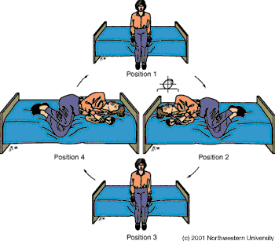
BRANDT-DAROFF EXERCISES (The first home treatment described for PC BPPV, but not the best)
Click here for a low bandwidth animation
The Brandt-Daroff Exercises are a home method of treating BPPV, usually used when the side of BPPV is unclear. It was proposed many years ago, when we didn't understand the mechanism of BPPV (Brandt and Daroff, 1980). Their use has been declining in recent years, as the home Epley maneuver (see below) is considerably more effective. They succeed in 95% of cases but are more arduous than the office treatments. We occasionally still suggest them for patients with atypical BPPV.
These exercises also may take longer than the other maneuvers -- the response rate at one week is only about 25% (Radke et al, 1999). These exercises are performed in three sets per day for two weeks. In each set, one performs the maneuver as shown on the right five times.
1 repetition = maneuver done to each side in turn (takes 2 minutes)
Suggested Schedule for Brandt-Daroff exercises
Time | Exercise | Duration
Morning | 5 repetitions | 10 minutes
Noon | 5 repetitions | 10 minutes
Evening | 5 repetitions | 10 minutes
Start sitting upright (position 1). Then move into the side-lying position (position 2), with the head angled upward about halfway. An easy way to remember this is to imagine someone standing about 6 feet in front of you, and just keep looking at their head at all times. Stay in the side-lying position for 30 seconds, or until the dizziness subsides if this is longer, then go back to the sitting position (position 3). Stay there for 30 seconds, and then go to the opposite side (position 4) and follow the same routine.
These exercises should be performed for two weeks, three times per day, or for three weeks, twice per day. This adds up to 42 sets in total. In most persons, complete relief from symptoms is obtained after 30 sets, or about 10 days. In approximately 30 percent of patients, BPPV will recur within one year. Unfortunately, daily exercises are not effective in preventing recurrence (Helminski and Hain, 2008). The Brandt-Daroff exercises as well as the Semont and Epley maneuvers are compared in an article by Brandt (1994), listed in the reference section.
When performing the Brandt-Daroff maneuver, caution is advised should neurological symptoms (i.e. weakness, numbness, visual changes other than vertigo) occur. Occasionally such symptoms are caused by compression of the vertebral arteries (Sakaguchi et al, 2003). In this situation we advise not proceeding with the exercises and consulting ones physician. It is also best to stop if one develops neck pain.
Multicanal BPPV (usually mild) often is a consequence of using the Brandt-Daroff exercises. This is probably because one does it over and over, and because the geometry is not very efficient. Lots of opportunities for rocks to go into the wrong place.
Other resources:
- Supplemental material on the site DVD: Animation of Brandt-Daroff exercises. Note that this treatment maneuver is done faster in the animation than in actual use. Usually one allows 30 seconds between positions.
- Supplemental material on the site DVD: Movie of Brandt-Daroff exercises
- We offer a home treatment DVD that illustrates the Brandt-Daroff exercises.

HOME EPLEY MANEUVER (the best home treatment maneuver)
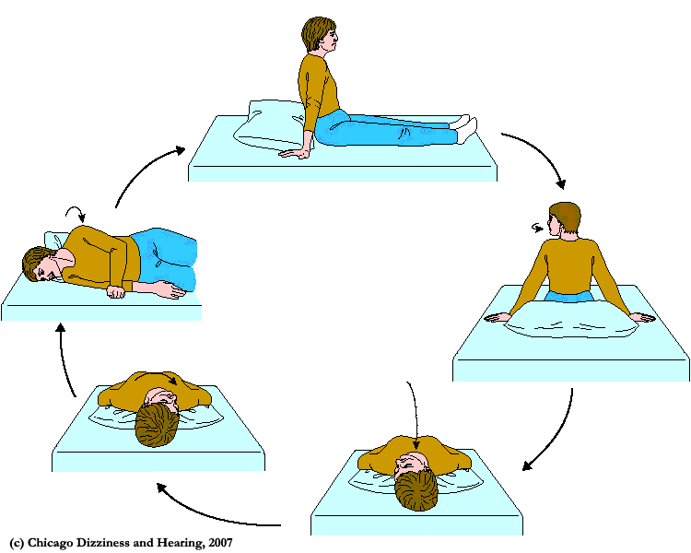
The Epley and/or Semont maneuvers can be done at home (Radke et al, 1999; Radke et al, 2004; Furman and Hain, 2004). We often recommend the home-Epley to our patients who have a clear diagnosis. This procedure seems to be even more effective than the in-office procedure, perhaps because it is repeated every night for a week. At this writing (2015) there are many home maneuvers. As there is only one way to move things around in a circle, they all boil down to the same head positions - -just different ways of getting there. The Epley maneuver is the best established.
The home Epley method (for the left side) is performed as shown on the figure to the right. The maneuver for the right side is just the mirror image.
One stays in each of the supine (lying down) positions for 30 seconds, and in the sitting upright position (top) for 1 minute. Thus, once cycle takes 2 1/2 minutes. Typically 3 cycles are performed just prior to going to sleep. It is best to do them at night rather than in the morning or midday, as if one becomes dizzy following the exercises, then it can resolve while one is sleeping.
We offer a home treatment DVD that illustrates the home Epley exercises.

HOME SEMONT MANEUVER (middle efficacy)
Radke et al (2004) also studied the home Semont maneuver, using a similar procedure as the home-Epley. They reported that the home-Semont was not as effective as the home-Epley, because it was too difficult to learn. The difference was quite remarkable: 95% for the Epley vs. 58% for the Semont. As the positions of the head are almost identical to the home-Epley, it should be equivalent. While we occasionally suggest it to patients, this is not one to learn from a web-page.

The "Foster" or half somersault maneuver. While it is on Youtube, the home Epley is better.
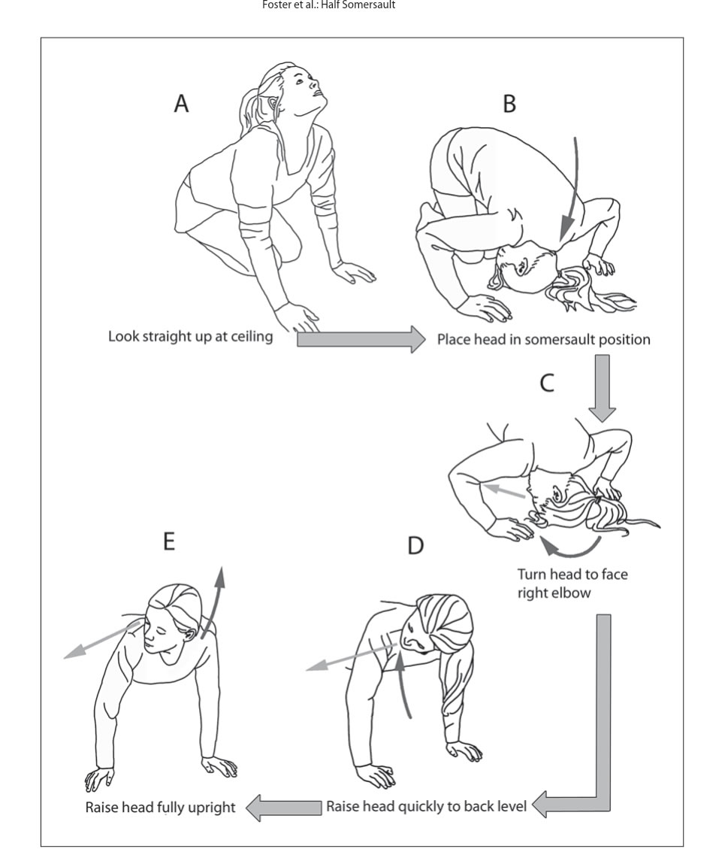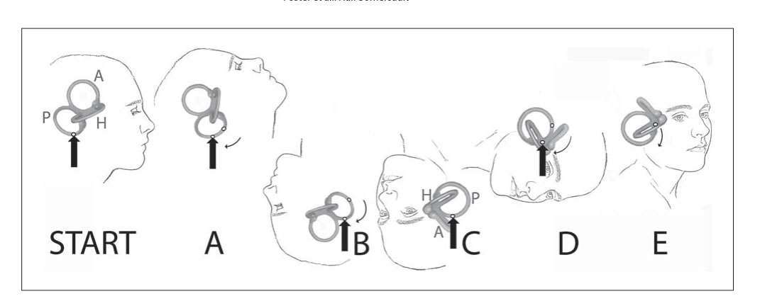
In 2012, Dr. Carol Foster reported another self-treatment maneuver for posterior canal BPPV, that she subsequently popularized with an online video on youtube. In this maneuver, using the illustrations above that she published in her 2012 article, one begins with head up, then flips to upside down, comes back up into a push-up position with the head turned laterally (actually 45 deg), and then back to sitting upright. Biomechanically, this is another way to get a series of positions similar to the Epley maneuver. The trick of it is that instead of putting the head far backward (as in the Epley), one puts the head very far forward.
The illustrations above are not very accurate in showing the positions (as described in the text of the article), or showing the position of the canals in the ear. In particular, position D makes it look as if the head should be turned 90 degrees on the trunk, but the article says turn the head 45 degrees on the trunk. This would be reasonable, but 90 degrees would not.
The Foster maneuver appears to require a bit more strength and flexibility to perform than the self-Epley maneuver reported by Radke (1999), or for that matter, nearly any of the other maneuvers. Of course, it doesn't really matter how you get your head into these positions - -as they all do the same thing. Other problems might be insufficient flexibilty to attain position A (with the head far back), or danger of falling over when one is dizzy in positions B-E. We have no idea how the Foster maneuver could prevent repeat bouts of BPPV -- as it was our understanding that this was just the natural history of BPPV (more rocks falling off). We just don't see how the Foster maneuver would stop this.
One might wonder if the Foster maneuver, which looks pretty close to the head-forward maneuver for anterior canal BPPV, might not also treat anterior canal BPPV. While we will not go into this much, the answer is no, the head is in the wrong place during position D.
Dr. Foster, in her published article (2012), stated that her half-sumersault maneuver is not as effective as the regular Epley maneuver, but patients prefer it anyway. Although it looks like a good arm workout, we don't see any particular reason to use or not use Dr. Foster's maneuver over any of the other recent home treatment BPPV maneuvers (i.e. home Epley, home Semont), as they all put the ear through very similar positions.

A Modest Proposal -- Another maneuver anyone ?
There seems to be considerable willingness in the literature to propose new maneuvers, often named after their inventor, that are simple variants of older maneuvers. Well -- there are still a few maneuvers left to adapt (:
If one is willing to engage in athletic positions as in the half-somersault procedure, why not just take things to the logical extreme and do a complete backward sumersault in the plane of the affected canal, starting from upright (A below), then to the home-Epley bottom position above (B below), then into the Foster position C -- midway between B and C below, and then follow through to position C below (which is also position D of the Foster and home Epley), and then finally to upright again. Stopping for 30 seconds in each position. A full circle. This is a home version of the Lembert 360 rotation described in 1997.
I propose naming it "The full circle maneuver". Or maybe the full backwards sumersault. We do not recommend that people try this maneuver out -- as there are some practical issues (i.e. getting from position B to C) and we would not want anyone to hurt themselves. But it should work just as well as the others, as the positions of the head are the same. And thats the only thing that matters when one considers the efficiency of these maneuvers.
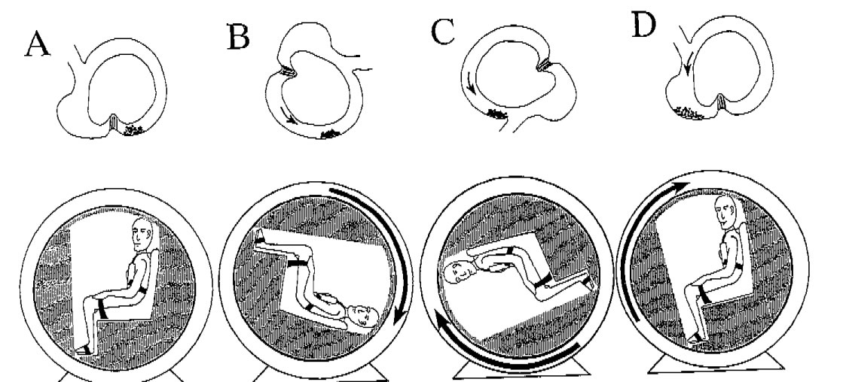
Illustration of the 360 rotation of the left posterior semicircular canal, From Lempert et al, 1997.

References
- Brandt T, Daroff RB. Physical therapy for benign paroxysmal positional vertigo. Arch Otolaryngol 1980 Aug;106(8):484-485.
- Brandt T, Steddin S, Daroff RB. Therapy for benign paroxysmal positioning vertigo, revisited. Neurology 1994 May;44(5):796-800.
- Foster CA, Ponnapan A, Zaccaro K, Strong D. A comparison of two home exercises for benign positional vertigo: Half somersault versus Epley Maneuver. Audiol Neurotol Extra 2012;2:16-23
- Furman, J. M. and T. C. Hain (2004). ""Do try this at home": self-treatment of BPPV." Neurology63(1): 8-9.
- Helminski JO, Hain TC. Daily exercise does not prevent recurrence of Benign Paroxysmal Positional Vertigo. Otol Neurotol 29:976-961, 2008
- Lempert T, Wolsley C, Davies R, Gresty MA, Bronstein AM. Three hundred sixty-degree rotation of the posterior semicircular canal for treatment of benign positional vertigo: a placebo-controlled trial. Neurology 1997 Sep;49(3):729-733.
- Radtke, A., et al. (1999). "A modified Epley's procedure for self-treatment of benign paroxysmal positional vertigo." Neurology 53(6): 1358-1360.
- Radtke, A., et al. (2004). "Self-treatment of benign paroxysmal positional vertigo: Semont maneuver vs Epley procedure." Neurology 63(1): 150-152.

