Sports Injuries Treatment & Rehabilitation | Virtual Sports Injury Clinic

Dislocated Shoulder rehabilitation Guidelines

Stage 1 (days 0 – 7)
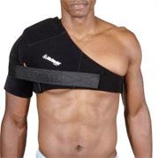
- Following reduction, your shoulder should be immobilized in a sling for at least a week. Exactly how long will depend on the severity of your injury.
- Performing wrist and hand exercises such as moving each finger through its range of motion and clenching the fist will prevent stiffness and keep blood flowing to the area.
- Continue applying cold therapy regularly to reduce pain and swelling.
- A doctor may prescribe anti-inflammatory medication to reduce pain and inflammation.
- Taping your shoulder joint may also help give extra protection, as might a heavy duty shoulder support.

Stage 2 (weeks 2 to 4)
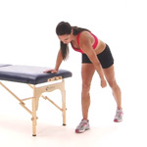
- When pain allows mobility exercises can begin, usually starting with simple pendulum exercises.
- Avoid the combined movements of abduction (taking the arm out to the side) and external rotation (turning the shoulder outwards).
- This is often the position a dislocated shoulder occurs in the first place, so is likely to happen again if you are not careful.
- Only exercise if your shoulder is pain-free and continue to wear a sling when not performing exercises if necessary.
- Apply ice after exercise if swelling occurs.

Stage 3 (weeks 4 to 6)
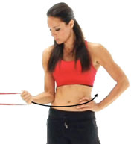
- The aim here is to begin to restore strength the muscles and achieve full range of motion in your shoulder.
- Begin isometric or static strengthening exercises providing there is no pain.
- Begin to move your shoulder into abduction and external rotation if comfortable to do so. But do not perform strengthening exercises in this position!
- Continue with mobility exercises and try to achieve a full pain-free range of movement.
- One of the most important exercises is medial rotation in the internal range of movement. It is vital that strength is built up in this inner range to avoid future shoulder dislocations.
- Avoid wearing a sling now if possible.
- In addition to rotator cuff exercises, it is important to do regular scapular stabilization exercises. There are literally dozens of shoulder rehabilitation exercises.

Stage 4 Dislocated shoulder rehabilitation (weeks 6 to 10)
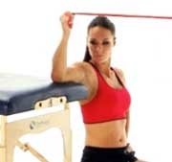
- During weeks 6 to 10, aim to achieve strength equal to the uninjured side, and maintain mobility.
- Progress strengthening to resisted exercises if pain-free.
- Start external rotation strengthening in the abducted position if comfortable.
- Continue with mobility exercises to maintain a full range of motion Introduce proprioception exercises.

Stage 5 Dislocated shoulder rehabilitation (Weeks 10 – 16)
- Aim to return to normal activities of daily living
- Increase resistance used for strengthening, progress to dumbbells and body weight exercises

